**Add a new country**

**Step-1:** Created new method addCountry() in countryService

@Transactional

**public** **void** addCountry(Country country) {

countryRepository.save(country);

}

**Step-2**:Created new new testAddCountry() method in OrmLearnApplication

**private** **static** **void** testAddCountry() {

***LOGGER***.info("Start testAddCountry");

Country newCountry = **new** Country();

newCountry.setCode("CG");

newCountry.setName("Cognizant-Girish");

*countryService*.addCountry(newCountry);

**try** {

Country country = *countryService*.findCountryByCode("CG");

***LOGGER***.debug("Added Country: {}", country);

} **catch** (CountryNotFoundException e) {

***LOGGER***.error("Exception: {}", e.getMessage());

}

***LOGGER***.info("End testAddCountry");

}

**Output:**

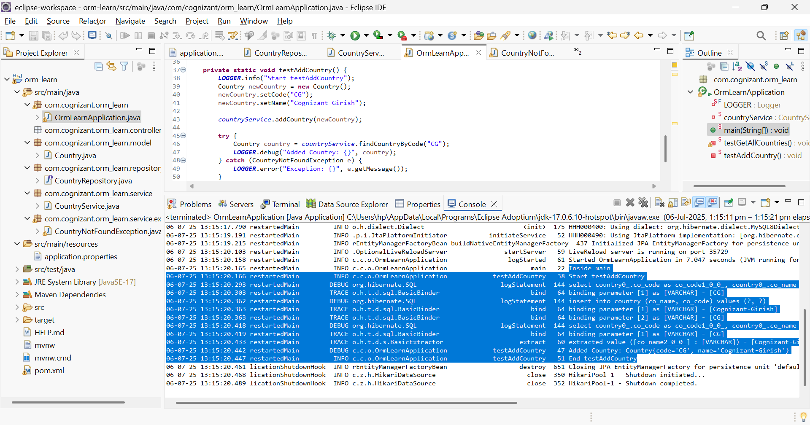

Added new Cognizant-Girish Country with CG code